7/27/17
• • • 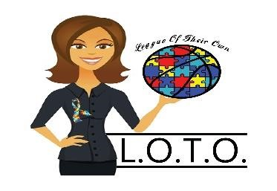
L.O.T.O. Inc.
League of Their Own
PO Box 302
Guyton, GA 31312

Re: Sponsorship 2nd Annual Tournament of Legends
Dear Ms. Hurd:
It is with great pleasure that I offer your organization a great opportunity to become a valuable sponsor of L.O.T.O. Inc. (League of Their Own). L.O.T.O. is a 501(3)(c) non-profit organization dedicated to introducing uniquely challenged students with disabilities to sports. We help to build their encouragement and introduce sportsmanship, teach fundamentals, and develop social skills, also allowing friendships to foster, increasing physical agility, and strengthening communication skills, while creating lifetime memories for both the parents and athletes.
L.O.T.O. Inc. have been quite busy seeking to spread awareness of a diagnosis that affects 1 in every 63 children, more highly diagnosed in male children. With an intense sense of urgency, L.O.T.O. has really hit the ground running and has been diligently working in the last year and half. We have joined with local businesses in the Savannah, GA area to provide assistance and much needed services to comfort the families affected by Autism and Down Syndrome:
L.O.T.O. Inc. “League of Their Own” also believes in paying it forward and being a visible presence in our community and have provided sponsorship to a father and daughter to attend “The Father and Daughter Tea Party” as well as a “Stop the Gun Violence Campaign” held in downtown Savannah. After hurricane Matthew we donated clothing to the Westlake community.
It is very important to provide mentorship to our uniquely challenged and help bridge the gap in the special needs community. The autism spectrum includes: Asperger’s Syndrome, PDD (pervasive developmental disability) non-verbal and sensory processing disorders. Other diagnosis that some of our children face so courageously are ADD (attention deficit disorder), ADHD (attention deficit hyperactivity disorder), ODD (oppositional defiance), Down ’s syndrome, and those who are wheelchair bound.
Socialization is key in helping to normalize their lives as much as possible and since many of the children can go on to lead fulfilling lives independently; additional time, skill and expertise is greatly sought after. We have student mentors that play on the team. Student mentors help with fundamentals, communication, best buddy and assist with homework.
As you can see, the development of this organization is no small undertaking and can provide a much-desired quality of life that our unique athletes seek. With your sponsorship, L.O.T.O. will include your organization logo on our marketing materials and verbal recognition throughout the community at every function held.
Our 2nd Annual Tournament of Legends will take place this year on November 11, 2017. Last year event was a huge success with professional athletes like Travis Best from Indiana Pacers, Brian Jordan from Atlanta Braves, Larry Gator Rivers from Harlem Globetrotters and Tony Womack from Pittsburgh Pirates. The Gator Ball Academy helps tremendously with our unique athlete in skill and self -confidence. The money raised last year helped with our Journey to Atlanta to see the Atlanta Hawks, Father and Daughter; Mother and Son brunch and Magical Moments Prom Night. OK, so what I need from you? Is for you to believe in our vision, drive, passion, and determination to make this league “League of Their Own”. To be more widely recognized in not only Savannah and surrounding counties, but potentially nationwide.
Supporting upcoming event, purchasing equipment, supporting a unique athlete in camp and rental of gym. I look forward to your sponsorship and you sharing your blessings with unique athletes.

Thank you in advance,

S. M. Freeman-Jones

Sinolla M. Freeman-Jones
CEO/Founder
L.O.T.O. Inc. “League of Their Own"
912-376-9629 (O)
912-481-2361(C)
www.lotoleagueinc.weebly.com

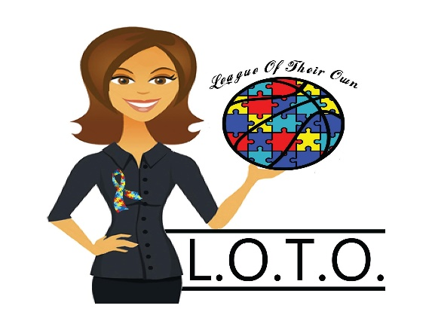

Sponsorships

HOW CAN YOU HELP?
A League of Their Own, Inc. is a non-profit organization creating a special sports league for children with disabilities. Acting alone, we cannot reach every individual unique athlete with the necessary funds to serve our unique athletes with an effect impact. But, with the investment of caring individuals and organizations, we will bring “A League of Their Own” to Savannah youth with disabilities and youth’s around the nation. A new and eye-opening experiences through building character, friendships, sportsmanship, life skills, physical agility and a lifetime of memories in the unique athlete. “Bridging the gap between disabilities and sports.” As an IRS 501(c)(3) tax-exempt organization, your contributions may be fully tax deductible.

SPONSORSHIP LEVELS

Our sponsorship levels are designed to allow everyone to participate in supporting our unique athletes:

Platinum LOTO Team / $7,500 or more

- Radio advertisement
- Web Page listing
- Venue banner
- Media & Print recognition in all promotion
- 10 General admission tickets
- 5 VIP Tickets
- Option to speak at event
- Recognition during the event
- Ability to distribute product during event
- Company/ Organization logo on (1) Backboard
- Company/Organization logo on staff and volunteer shirts
- VIP Access Pre-game meet and greet with celebrities
- Company/ Organization logo on tickets
- 10 Event tournament T-Shirts

Gold League Draft / $3,500

- Verbal recognition during the event
- Company/ Organization logo on staff and volunteer shirt
- 3 VIP Tickets
- 5 General admission tickets
- Venue banner
- Media & Print recognition in all promotion
- 5 Tournament event T-Shirts
- Logo on promotional items
- Opportunity to distribute company product

Silver College Basketball Team / $1,000

- Company/ Organization logo on staff and volunteer shirt
- 2 VIP Tickets
- 3 General admission tickets
- Venue banner
- 2 Event tournament T-Shirts

Bronze High School Team: / $500

- 2 VIP Tickets
- 2 General admission tickets
- Venue banner
- 2 Event tournament T-Shirts
- 1 parking pass

Designated Scholarship / $1,000-$4,999

- Named individual scholarship to a L.O.T.O. unique athlete, honoring or memorializing an individual or group

Basketball and Colorful Shoelaces: Donations $25 or more

Interested in becoming a sponsor with L.O.T.O., Inc. “League of Their Own”?
Please contact S. Monique Freeman-Jones for more information at: kidsloto2015@gmail.com.

Payable to: L.O.T.O. Inc. League of Their Own, Inc.
Post Office Box 302
Guyton, Georgia 31312
(912) 379-9629 (O)
(912) 481-2361 (C)

We look forward to partnering with you to ensure the success of the unique athletes with disabilities in Savannah, Georgia and South Carolina. Thank you in advance for your support.

UPCOMING EVENTS:

- May 12, 2017- Magical Moments Prom Night
- August- 2017 Bow-tie for-a-Cause
- November 11, 2017 2nd Annual Tournament of Legends
- March 2018- L.O.T.O. Day with Atlanta Hawks
- May 12, 2018- Magical Moments Prom Night
- June 16-17, 2018 Father’s Day Golf Tournament

